**Cover Page**

**COMPSCI 345 / SOFTENG 350 Human-Computer Interaction**

**Assignment Three: Realizing a Design**

**Student Name:** Wannachai Burke

**Student ID:** 9620732

**Student UPI:** wbur788

____________________________________________________________________

Note: To ensure a fair playing field for all students in the class the University of Auckland will not tolerate cheating or assisting others to cheat, and views cheating in coursework as a serious academic offence.

Student Declaration:

* I declare that this work is my own work and reflects my own learning.
* I declare that where work from other sources (including sources on the world-wide web) has been used, it has been properly acknowledged and referenced.
* I understand that my assessed work may be reviewed against electronic source material using computerised detection mechanisms.

Place this page in the front as the first page of your document that you are submitting to Canvas

**Task One: Design Documentation**

Published Link: http://shakespeareacademy.azurewebsites.net/

1. Walkthrough

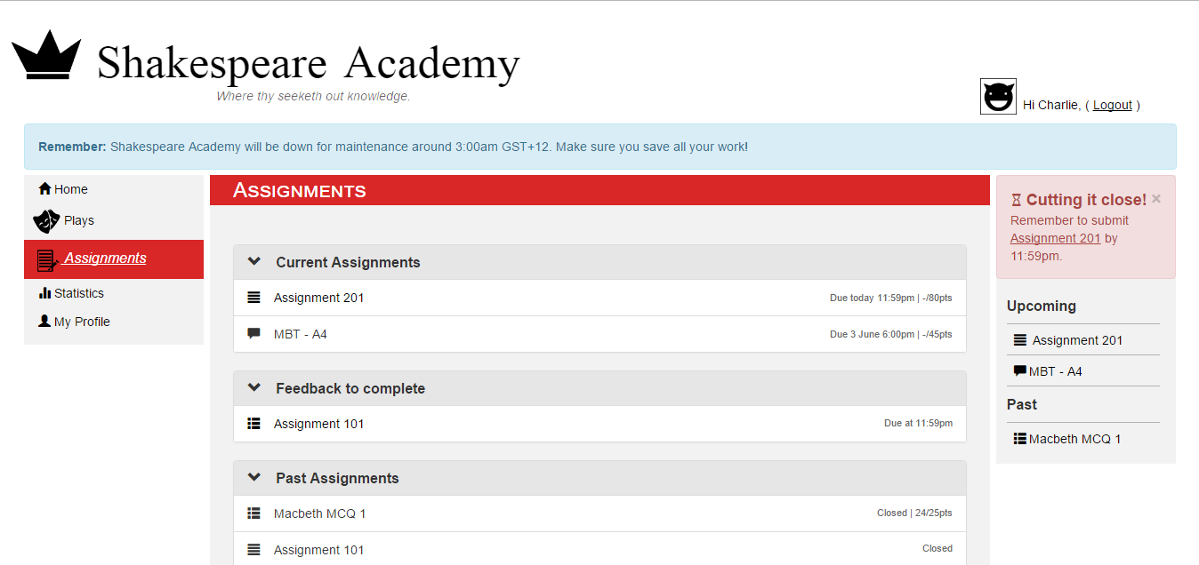First the user would navigate to the ‘Assignments’ tab using the navigation bar on the left, which turn brings up the ‘Assignments’ page where the user can see their current assignments, feedback to complete, and past assignments. The user would then select an assignment to go to the specific assignment page.

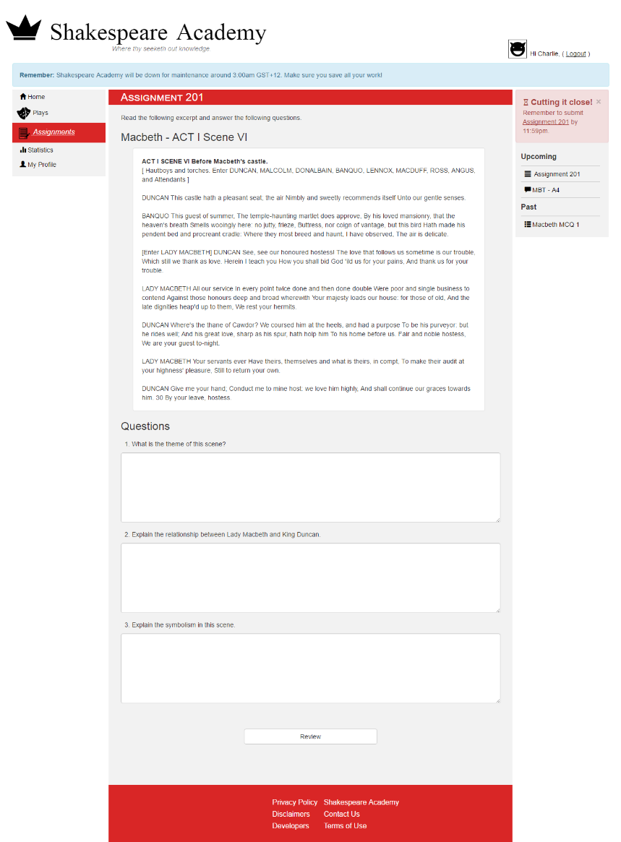

Upon clicking the specific assignment page, the user is presented with an excerpt from the play, which they must read and understand and then proceed to answer the following short questions.

Users are also required to answer all questions, otherwise they will not be able to proceed to review their answers and subsequently submit their assignment. Attempting to submit empty answers will result in an error which can only be resolved if they input some text into the text boxes.

Clicking ‘Review’ after entering your answers into the questions for the assignment, brings you to review your answers, where you are able to read over your answers to double check. If the user feels like the answer is inadequate they can choose to edit it, where it will enable the textboxes for editing. When satisfied, the user clicks submit. The user is then presented with a message to confirm that the assignment has been successfully submitted.

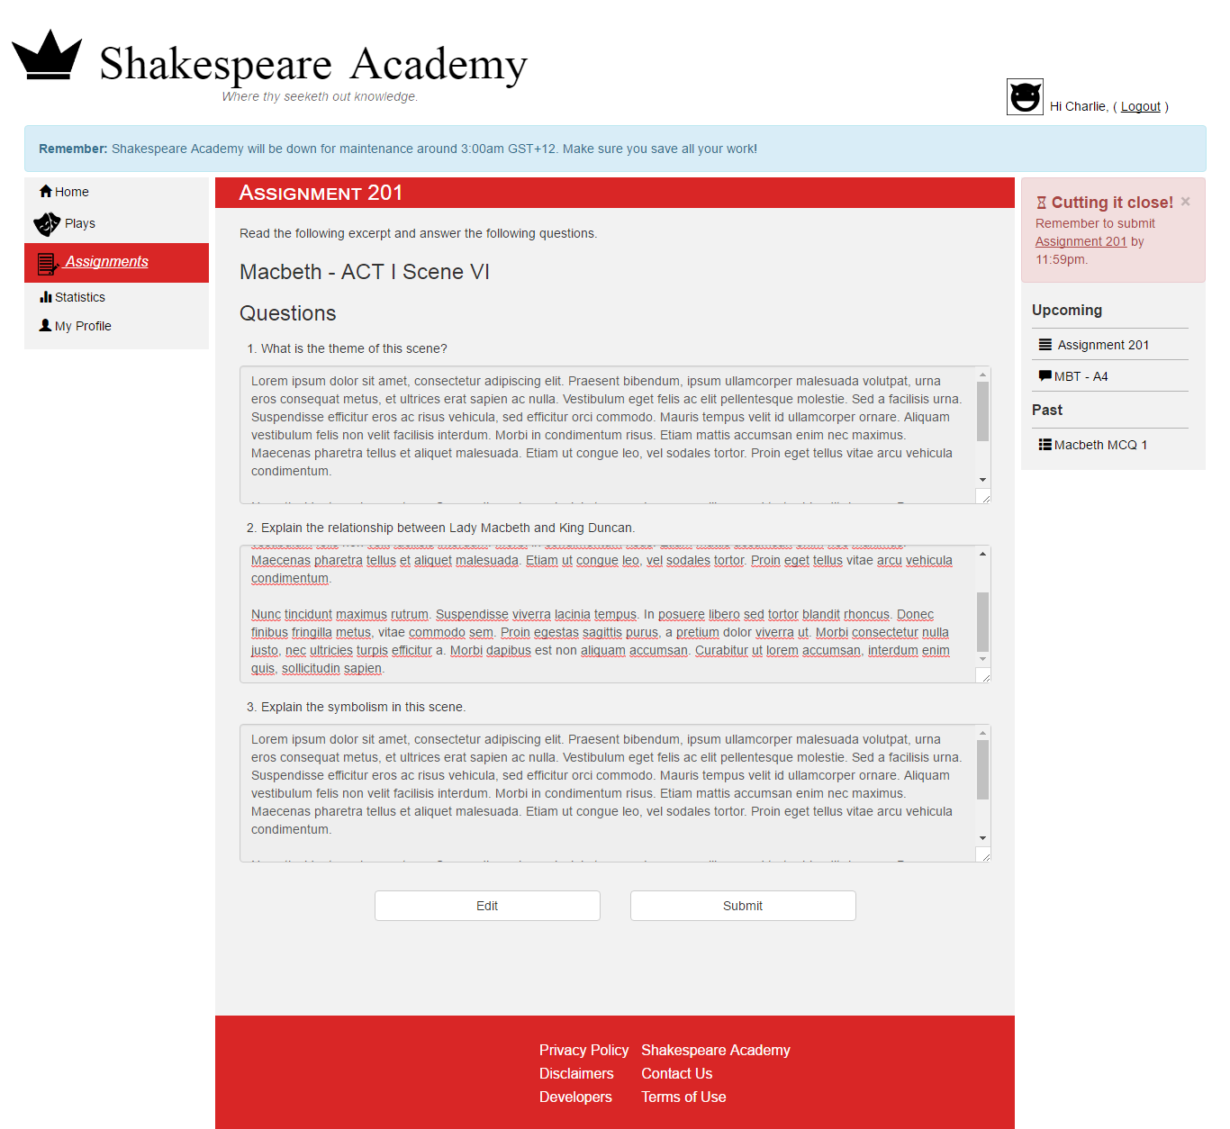

The user can also give feedback on their peers’ answers. The user must first navigate to the ‘Assignment’ tab from the navbar and then select an assignment to give feedback to from the ‘Feedback to Complete’ section. The user is presented with a table of peers who have/have not completed the peer review, as well as the response to provide feedback to. After reading the response, the user submits their feedback.

Upon submitting feedback, the status in the table is updated accordingly.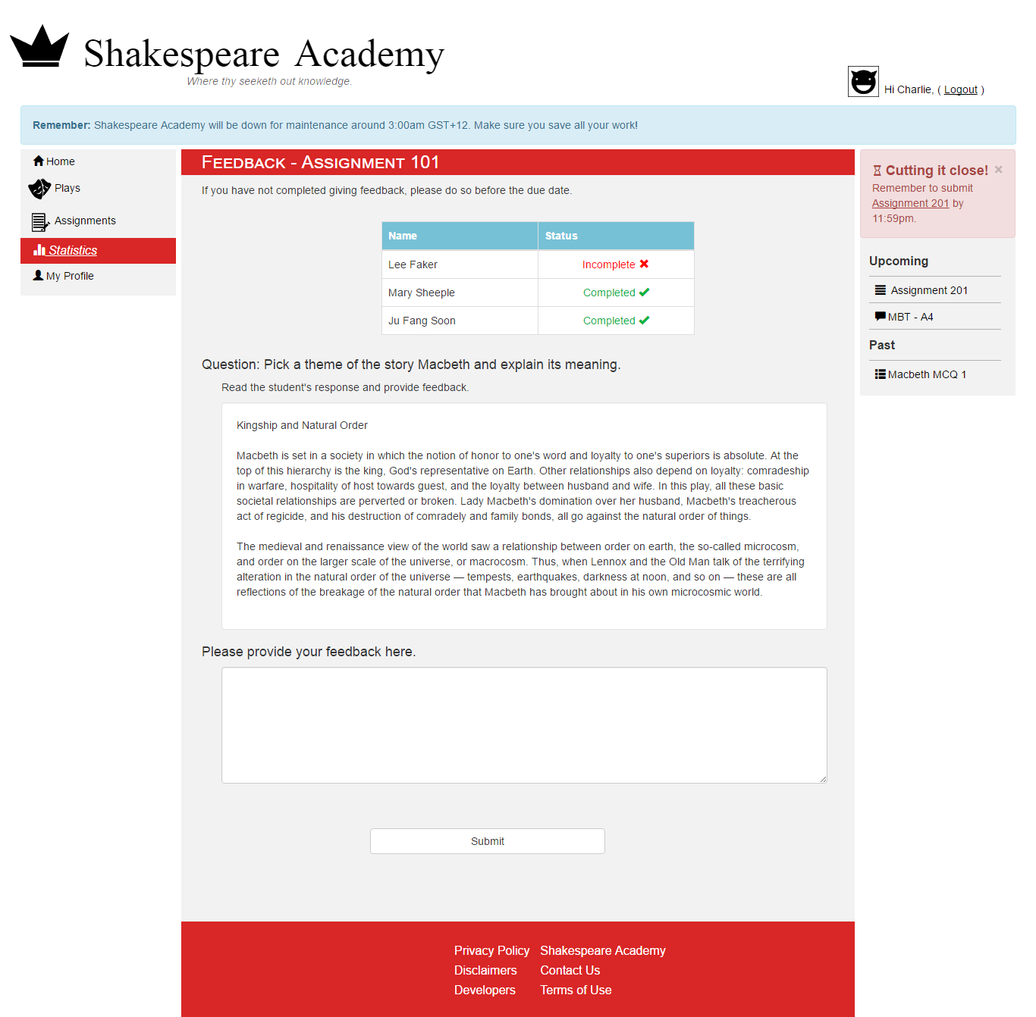

The user can also click on the ‘Plays’ tab from the navbar in order to find a list of plays that can provide information about the specific play. This includes the full text, a summary and notes about themes, motifs & symbols, and characters. Clicking full text brings up a modal window, that provides a platform to read the text. Different notes can also be shown and hidden using the accordion.

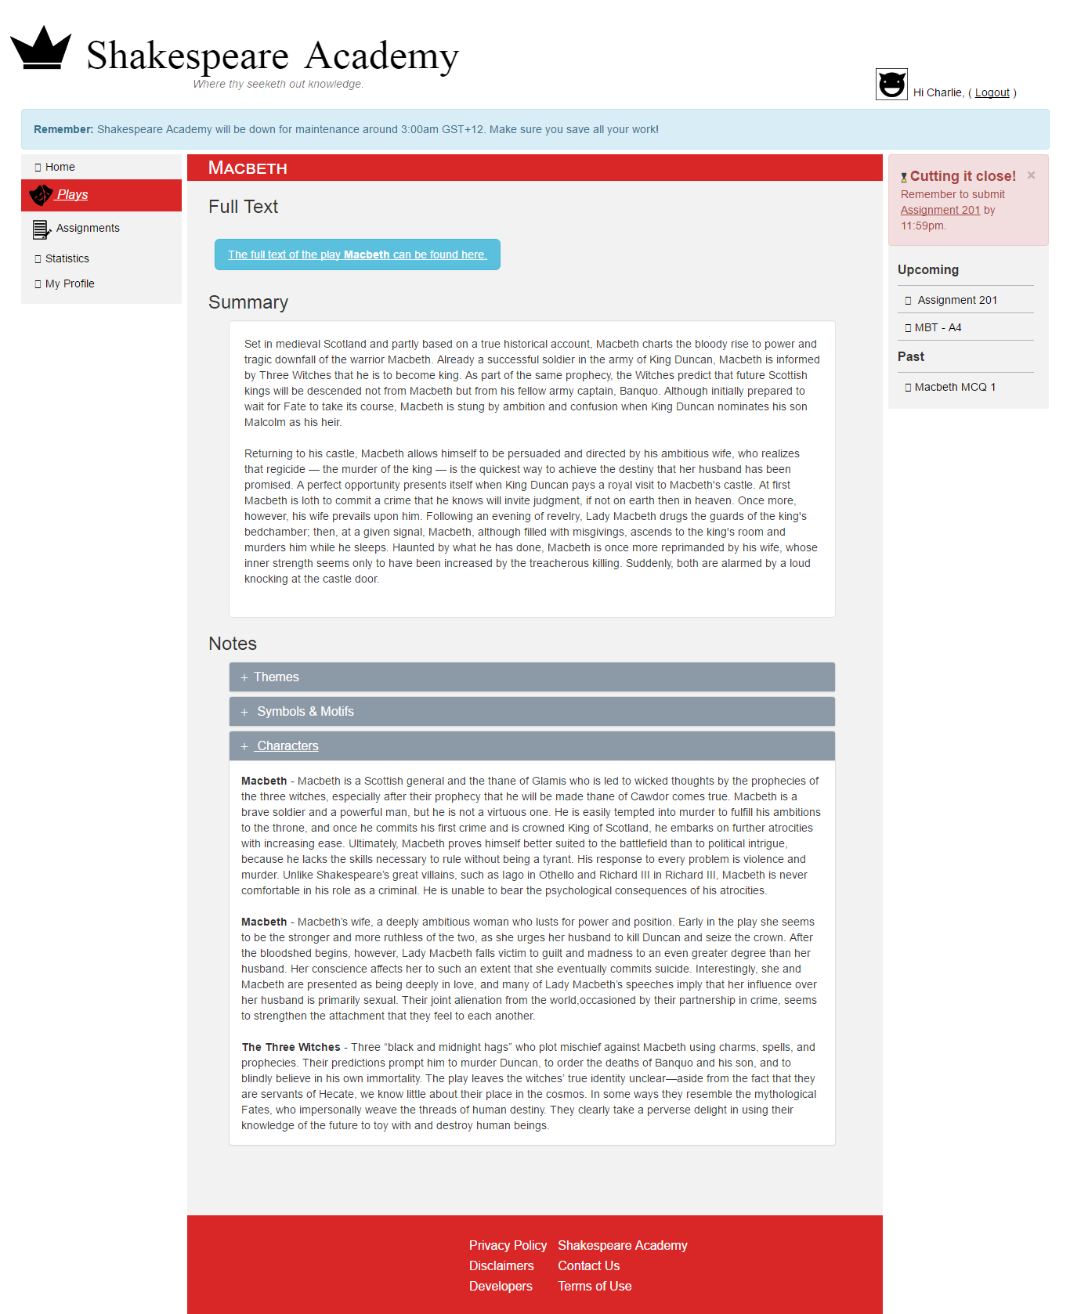

**Out of Scope:**

* The pages ‘Statistics’ and ‘Profile’ are an important part to the learning domain but are not within scope, so they only contain headers.
* The links on the footer of each page, act as hyperlinks but do not lead anywhere since they are not considered important for this prototype.

**Functionality:**

* In the ‘Plays’ page, the table rows are not clickable, but they should be. The sorting buttons work, as well as the live search bar. Also, the **only clickable button** there is the ‘Macbeth’ button at the top of the page.
* The modal window when clicking ‘Full Text’ for Macbeth works, with interactive pages.
* In Assignments, only the ‘Assignment 201’ and ‘Assignment 101’ are clickable for different scenarios.
* Ideally, upon submitting Assignments, it should move to Past Assignments, but I have not implemented that in this prototype.
* Also, on the right column (on every page), only the ‘Assignment 201’ is clickable, and leads you to the Assignment 201 page.

1. The colour scheme I used for the website revolves around using white, greys, blues and red for various elements. I used a darkish red for indicating important blocks, such as the active tab on the navigation bar, as well as headers and footers. I also used various colours of blues for table headers, and buttons related to tables. The choice in these colours allowed for distinct contrast in functionality and commands user attention. Red and blue can usually clash with each other, but I think I have successfully chosen shades that complement each other. I also used a light grey to indicate main body areas.

 

rgb(217, 38, 38) rgb(238, 245, 247)

1. In my design, I have spent an extensive time working on different containers and aligning them perfectly to clearly define different areas with varying information. My design has mostly sharp edges for a slicker look, but also contains some rounded edges on buttons to balance out the design. Margins are clearly defined in my design to help in grouping of different elements as well as give sufficient spacing between elements.

I have used clearly defined headers on pages (eg. Home) to clearly separate different parts of the pages. White space can be found between the Reminder message, navbar, main body, and right column in order to provide more clarity for different functioning containers.

1. The fonts I used were the basic ones, mainly Arial because sans serif give the design an overall simple and sleek look. However, I did use Times New Roman for the Logo Name in a much larger font to differentiate it from other texts. I also used Small caps for headers to give it a more distinct look as an important part of the page. I have made hyperlinks underlined to provide more affordance for clicking, as well as bolding table headers to tell them apart from the table rows. On pages I have also used various different sizes.
2. The following resources were used:
   * https://www.w3schools.com - W3Schools for assorted sections available in the tutorials including: Sort Table, BS Buttons, BS Glyphicons, BS Panels, BS Dropdowns, BS Tabs/Pills, BS Navbar, BS Forms, BS Modal
   * <https://stackoverflow.com/questions/9127498/how-to-perform-a-real-time-search-and-filter-on-a-html-table>
   * http://getbootstrap.com/ - For use of Bootstrap

Various links for Macbeth related information

* + <http://www.opensourceshakespeare.org/views/plays/plays.php>
  + <http://www.shakespeare-online.com/plays/macbeth_1_1.html>
  + <http://www.sparknotes.com/shakespeare/macbeth/themes.html>
  + <https://www.cliffsnotes.com/literature/m/macbeth/critical-essays/major-themes>